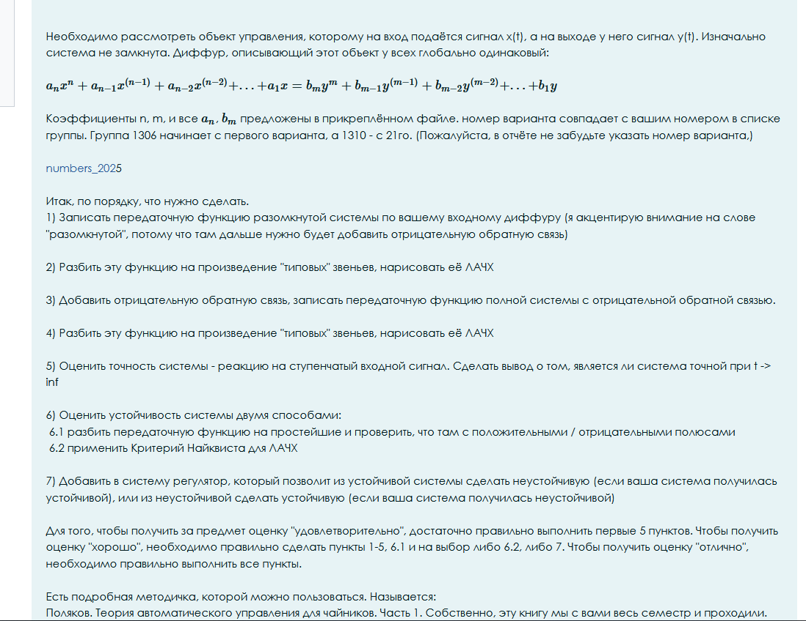

Variant number 25
n = 4
m = 6
a =

6 -7 5 -5

b =

-8 -10 -8 6 10 8

